**CSC318 – WEB APPLICATION DEVELOPMENT**

**QUIZ 1**

Write an html codes that will exactly appear as Figure 1 below.

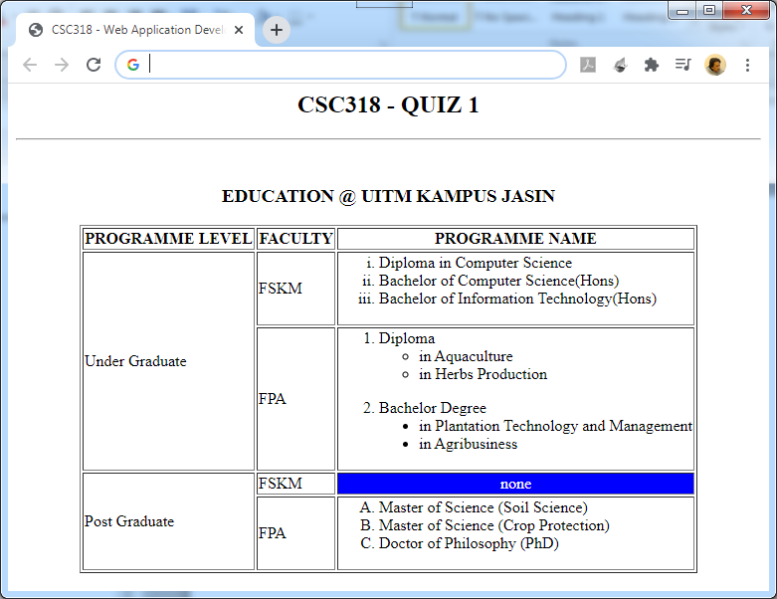

Figure 1: Education at UiTM Kampus Jasin

[20 Marks]

**Important:**

* Named the work file based on your matric number & name
* Only answer with pdf file format will be accepted.
* Example: 2018999000_AzmiBinAminordin.pdf